ASR 6107 JNJLDC

Case booking summary report

Request:

The Franchise filter for the "booking summary sheet" is not working. Would like to allow filter of different franchise in this report as customer is requesting for this information

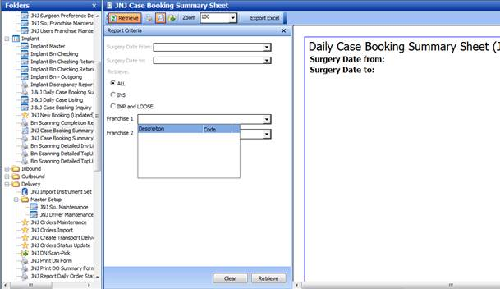

Changes:

2 reports:

Both report to include SPINE franchise

1. JNJ Case Booking Summary Sheet
2. JNJ Case Booking Summary Sheet1

JNJ Case Booking Summary Sheet

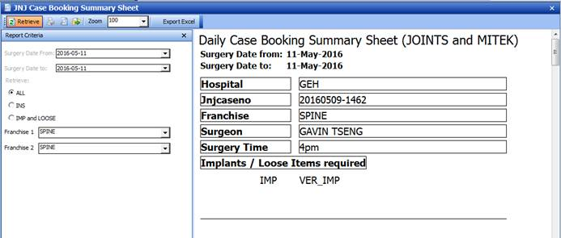

JNJ Case Booking Summary Sheet1

